TWELFTH ANNUAL

LOVESOM E

|  |  |  |
| --- | --- | --- |
|  | GOLF OUTING  2023 |  |
| **Kenton County Golf Course - Willows** | | |
| AT 17th June 2023 PER PERSON  8:00AM SATURDAY $125 | | |
| REGISTER ONLINE AT HTTPS://TINYURL.COM/RDWD5SB2 | | |

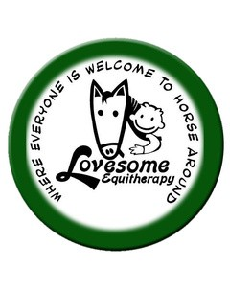

TWELFTH ANNUAL

LOVESOME

GOLF OUTING

Sponsorship Information

All event sponsors will have a hole sponsorship sign displayed at the event which will highlight their organization and level of support.

GOLD SPONSOR: SILVER SPONSOR: $300 BRONZE SPONSOR: $150

$500

# We want to be a

Name:

# _ sponsor!

Company: Phone: Address: Email:

Forms and checks can be mailed to Tracy Osborne at 17 Glazier Rd., Ft. Wright, KY 41011. All checks should be made out to Lovesome Stables. Online payments can be made at lovesomestables.com